Some useful links:

<https://docs.microsoft.com/en-us/azure/app-service/containers/quickstart-python?tabs=bash>

<https://docs.microsoft.com/en-us/azure/azure-cache-for-redis/cache-python-get-started>

<https://docs.microsoft.com/en-us/azure/sql-database/sql-database-load-from-csv-with-bcp>

<https://docs.microsoft.com/en-us/azure/azure-cache-for-redis/cache-configure>

<https://www.microsoft.com/en-us/download/details.aspx?id=56567>

<https://docs.microsoft.com/en-us/sql/connect/odbc/linux-mac/install-microsoft-odbc-driver-sql-server-macos?view=sql-server-ver15>

Command:

python3 -m venv venv

source venv/bin/activate

pip install -r requirements.txt

export FLASK_APP=application.py

flask run

For creating resource file on azure,

az webapp up --sku F1 -n asign190 -l "Central US"

az webapp log config --name asign190 --resource-group nilammakwana5_rg_Linux_centralus --docker-container-logging filesystem

az webapp log tail --name asign190 --resource-group nilammakwana5_rg_Linux_centralus

https:// asign190.scm.azurewebsites.net/api/logs/docker

For Database set up,

Commad :

brew untap microsoft/mssql-preview

brew tap microsoft/msodbcsql <https://github.com/Microsoft/homebrew-mssql-release>

brew update

brew install mssql-tools

commad from Microsoft website,

/usr/bin/ruby -e "$(curl -fsSL https://raw.githubusercontent.com/Homebrew/install/master/install)"

brew tap microsoft/mssql-release https://github.com/Microsoft/homebrew-mssql-release

brew update

HOMEBREW_NO_ENV_FILTERING=1 ACCEPT_EULA=Y brew install msodbcsql17 mssql-tools

**Load data from CSV into Azure SQL Database (flat files)**

<https://docs.microsoft.com/en-us/azure/sql-database/sql-database-load-from-csv-with-bcp>

sqlcmd.exe -S <server name> -d <database name> -U <username> -P <password> -I -Q "

CREATE TABLE DimDate2

(

DateId INT NOT NULL,

CalendarQuarter TINYINT NOT NULL,

FiscalQuarter TINYINT NOT NULL

)

;

"

## Create a source data file

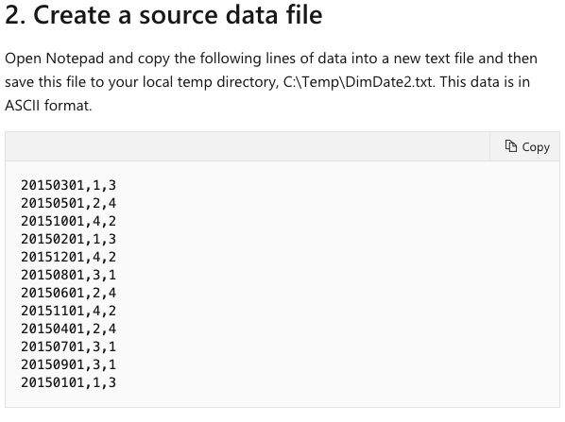

## Load the data

1)

bcp DimDate2 in C:\Temp\DimDate2.txt -S <ServerName> -d <DatabaseName> -U <Username> -P <password> -q -c -t ,

bcp DimDate2 in DimDate2.txt -S xyz.database.windows.net -d xyz -U xyz.database.windows.net -P password1 -q -c -t ,

Use this command to verify the data was loaded properly

2)

sqlcmd.exe -S <server name> -d <database name> -U <username> -P <password> -I -Q "SELECT * FROM DimDate2 ORDER BY 1;"

sqlcmd -S xyz.database.windows.net -d xyz -U xyz.database.windows.net -P password1 -I -Q "SELECT * FROM DimDate2 ORDER BY 1;"

sqlcmd -S xyz.database.windows.net -d xyz -U xyz.database.windows.net -P password1 -I -Q "DROP TABLE QUAKES;"

example 1

sqlcmd -S xyz.database.windows.net -d xyz -U xyz.database.windows.net -P password1 -I -Q "

CREATE TABLE QUAKES

(

TIME VARCHAR(255) NULL,

LATITUDE FLOAT(50) NULL,

LONGITUDE FLOAT(30) NULL,

DEPTH FLOAT(10) NULL,

MAG FLOAT(10) NULL,

magType VARCHAR(50),

NST FLOAT(10) NULL,

GAP FLOAT(10) NULL,

DMIN FLOAT(20) NULL,

RMS FLOAT(20) NULL,

NET VARCHAR(10) NULL,

ID VARCHAR(25) NULL,

updated VARCHAR(50),

PLACE VARCHAR(73) NULL,

type VARCHAR(50),

HORIZONTALERROR FLOAT(20) NULL,

depthError FLOAT(20),

magError FLOAT(20),

MAGNST FLOAT(20) NULL,

Status VARCHAR(50),

LOCATIONSOURCE VARCHAR(4) NULL,

magSource VARCHAR(50)

)

;

"

bcp QUAKES in /Users/neelam/Desktop/quakes02.csv -S xyz.database.windows.net -d xyz -U xyz.database.windows.net -P password1 -q -c -t ,

bcp QUAKES in /Users/neelam/Desktop/Quake.csv -S xyz.database.windows.net -d xyz -U xyz.database.windows.net -P password1 -q -c -t ,

example 2

sqlcmd -S xyz.database.windows.net -d xyz -U xyz.database.windows.net -P password -I -Q "

CREATE TABLE edu_share

(

Entity VARCHAR(255) NULL,

Code VARCHAR(255) NULL,

Year VARCHAR(255) NULL,

BLPercent VARCHAR(255) NULL

)

;

"

bcp edu_share in educationshare1.csv -S xyz.database.windows.net -d xyz -U xyz.database.windows.net -P passowrd1 -q -c -t ,

sqlcmd -S xyz.database.windows.net -d xyz -U xyz.database.windows.net -P passowrd1 -I -Q "DROP TABLE edu_share;"